Name:____________________________________________ Period:_________ Number:__________

1.2b – Notes on Squares and Square Roots

The Pyramid of Cholula is in Puebla, Mexico. It measures 1,690,000 ${ft}^{2}$ on the square base. How long would each side of the base be?

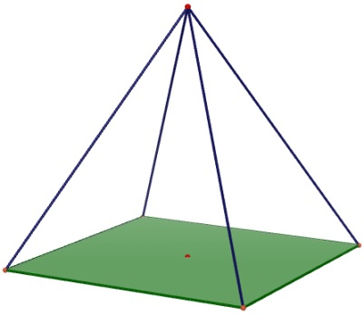

- A _________________________________ is_____________________________________________
____________________________________________________________________________________________________________________________________________________________________
EX #1:

Perfect Squares:

- A _____________________________ is ________________________________________________
____________________________________________________________________________________________________________________________________________________________________
EX#2:

EX#3:

RADICAL SIGNS:

EX#4:

EX#5:

EX#6:

