Math 8/8H
HW 1.4a
I can order rational and irrational numbers.

Put the following numbers in order from least to greatest (the order of a number line from left to right) by re-writing the numbers in the correct order:

- $-10$ 7 9 $-$4 0 ____________________________

- $17$ $-$29 43 $-17$ 0 ____________________________

- $1/5$ $-6/7$ 0.25 $-0.789$ 0 ____________________________

Plot each rational and irrational number on the number line.

- $-5/9$ $-{17}/4$ $-0.\overline{123}$ $-\sqrt{54}$ $-π$

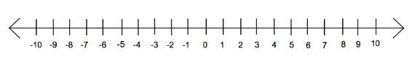
- $\sqrt{16}$ $\sqrt{24}$ 4.$\overline{2}$ $-2/5$ $-4 3/5$

- Sarah thought that -0.75 is bigger than -0.70. Is she right?___________ Explain why.

_______________________________________________________________________________________________________________________________________________________________________________________________________________________________________________________________

- Approximate the $\sqrt{89}$ as a fraction. Show your work.

