Name: ___________________________________________ Period: __________ Number: _________

2.1d Notes – Exponents and Parentheses

Throwin’ another one at ya! What do you think?
$${\left(4^{3}\right)}^{4}$$ | Thoughts???

WHAT DOES IT MEAN??________________________________________________________________
Write down what these mean, and then write the answer. Then see if we can come up with a pattern:
Question | What does it mean? | Answer
$${\left(x^{2}\right)}^{5}$$

$${\left(w^{5}\right)}^{3}$$

$${\left(y^{7}\right)}^{4}$$

$${\left(2^{5}\right)}^{2}$$

$${\left(b^{-3}\right)}^{3}$$

$${\left(2^{3}x^{2}\right)}^{4}$$

Power of a Power Rule:

What are the 5 steps now to solving problems with exponents?
- _____________________________________________
- _____________________________________________
- _____________________________________________
- _____________________________________________
- _____________________________________________

Do these two examples with your teacher. Then try the last one (with other peeps if you want) and show it to your teacher. CIRCLE YOUR ANSWERS!!
Ex #1:
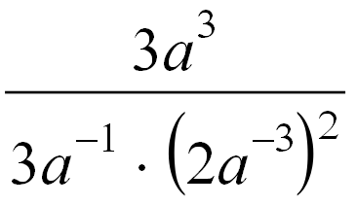

Ex #2:
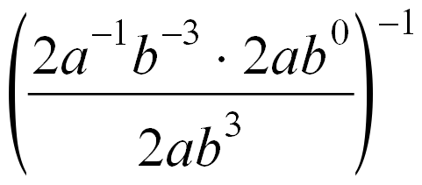

Ex #3:
