Math 8 / 8H
HW 3.1g

Solve each of the equations below and indicate whether it has one solution, no solutions, or infinite (many) solutions.

- $13-x=x-7$

  - One solution
  - No Solution
  - Many Solutions

- $8\left(2x-3\right)=4(4x-8)$

  - One solution
  - No Solution
  - Many Solutions

- $16-x=4x+8+3x$

  - One solution
  - No Solution
  - Many Solutions

- $-5\left(x-3\right)=-5\left(x-2\right)+5$

  - One solution
  - No Solution
  - Many Solutions

- $11+3x-7=6x+5-3$

  - One solution
  - No Solution
  - Many Solutions

- $2x-5x+4=4-3x$

  - One solution
  - No Solution
  - Many Solutions

- $0.2x+3.2=0.4x-0.2x+3.2$

  - One solution
  - No Solution
  - Many Solutions

- $8\left(2x-3\right)=4\left(4x-8\right)$

  - One solution
  - No Solution
  - Many Solutions

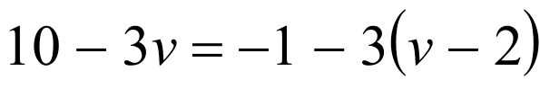

  - One solution
  - No Solution
  - Many Solutions

  - One solution
  - No Solution
  - Many Solutions

  - One solution
  - No Solution
  - Many Solutions

TRY: Solve it.

