Name: ___________________________________________ Period: __________ Number: _________

4.1b Notes – Linear Function or Not?

Comparing Graphs:
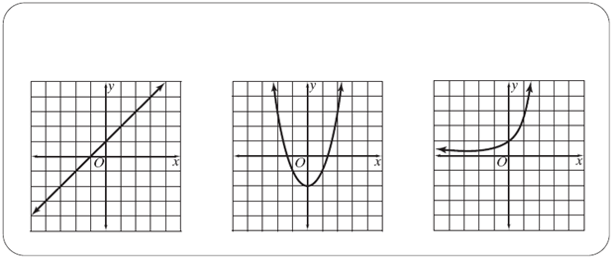

Look at equations and tables:

$$y=-\frac{2}{3}x+4$$ | $$y=\frac{1}{5}x-2$$ | $$y=x+1$$

How to tell if a function is linear:

Table | Graph | Equation

Decide if each of the examples represents a linear function. Just say YES or NO and give a little reason why.

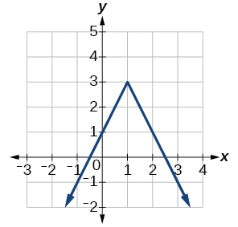 | $$2x-3y=17$$ | X Y  -2 10  0 7  2 4  6 -2  8 -5

