Name: ___________________________________________ Period: __________ Number: _________

4.1c Notes– Function Value
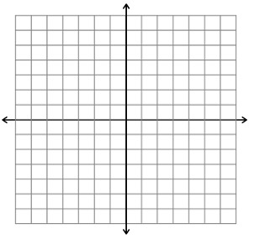
A pot of water at a temperature of 25 degrees Celsius is placed on a hot burner. The temperature of the water increases at a rate of 15 degrees per minute.

Equation: ________________________

X
Y

The _____________________ depended on the _____________________.
The _____________________ depended on the _____________________.
_____________________ is a function of _____________________.

You’re on a car trip in the middle of Kansas. You’re super bored so you decide to watch a couple of YouTube videos. There’s no Wi-Fi, but you say, “Eh, it’s the start of the month. I’ve got 2 GB of data.” Assume each YouTube video you watch uses 0.06 GB. Write an equation to represent how many GB of data you have left in the month.
Equation: ________________________
X
Y

The _____________________ depended on the _____________________.
The _____________________ depended on the _____________________.
_____________________ is a function of _____________________.
With Y and X,
The _____________________ depends on the _____________________.
The _____________________ depends on the _____________________.
_____________________ is a function of _____________________.

When you look at equations,

EX #1: With the equation$f\left(x\right)=2x+3$, find$f(4)$.

EX #2: With the equation$f\left(x\right)=x^{2}-4$, find$f(-7)$.

