Name: ___________________________________________ Period: __________ Number: _________

4.2a Notes – Slope

_______________ is another word for ____________________________________.

Look at this amazing graph down here!
- This is the graph of the line$y=2x$.  - Is it LINEAR? ____________  x y  - Let’s make a table.  - What is the slope? __________________ | 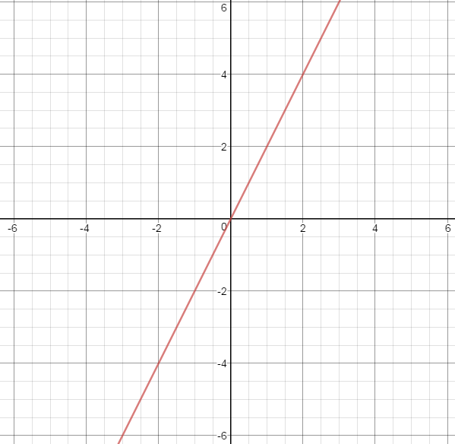

What are the other types of slope?

So…

Will your slope ALWAYS stay the same? __________________________
Explain why you think that.

EX #1: Graph the equation$y=5x$. EX #2: Graph the equation $y=\frac{1}{4}x.$
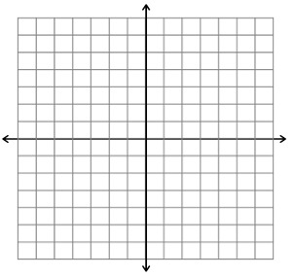

EX #4: Graph the equation $y=x.$ EX #5: Graph the equation $y=-2x.$

