Name: ___________________________________________ Period: __________ Number: _________

4.2b Notes – Graphing Linear Equations

Look at the following equations. Circle any linear equations.
$$y=4x-3$$ | $$y=2+\frac{2}{3}x$$ | $$y=\frac{-3}{x}$$

Why is/are the one(s) you circled linear? __________________________________________________
What will the shape of the graph be? _____________________________________________________
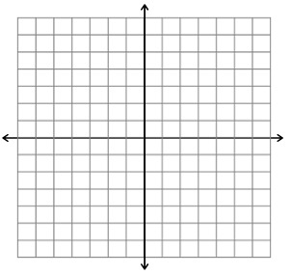  x y | x y

The equation of any linear equation can be written in the form: __________________________.

_______________ is another word for ____________________________________.

The _____________________________ is where the graph intersects the ___________.
EX #1:

NOW, HERE’S THE BIG QUESTION:
COULD YOU GRAPH IT WITHOUT THE TABLE?

EX #2: Graph the equation$y=5x-3$. EX #3: Graph the equation $y=-\frac{1}{3}x+2.$

EX #4: Graph the equation $y=x-3.$ EX #5: Graph the equation $y=-x+5.$

