Name: ___________________________________________ Period: __________ Number: _________

4.3a Notes – Writing Equations from a Context

I went to a water park and when I got inside, I wanted to rent an inner tube for the day. They told me I had to pay $__________ up front, then $1.50 for every hour. I know that after 6 hours, the TOTAL cost for the tube was $15. Can you make a table, graph, and equation to represent what happened to me today?

x y  Initial Value ( ): _________  Slope: ______________  Equation: _______________________ | 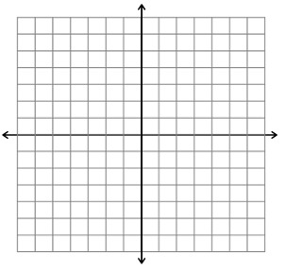
Ex #1: I wanted to buy some bacon-flavored chapstick online. They were $1.50 each, and then no matter how many I bought, the shipping was always $_______. Make a table from this info, and then write an equation.
x y | Initial Value: _________  Slope: ______________  Equation: _______________________  What does the slope represent?
What does the initial value represent?
Ex #2: My family wanted to rent a cabin up in Park City. The cabin we rented (cause I’m supes rich) cost us $__________ up front plus $475 per night after that. Make a table for renting it for 6 days and then make an equation from it.

x y | Initial Value: _________  Slope: ______________  Equation: _______________________  What does the initial value represent?
What does the slope represent?

Ex #3: Make an equation from this table.  x y  Equation: _____________________ | Ex #4: Make an equation from this table.  x y  Equation: _____________________

