Name: _____________________________________________ Period: __________ Number: __________

Math 8 / 8H
4.3a HW

- Eli helped his mom make gingerbread sasquatch cookies for a bake sale. His mom was supes quick. Answer the questions below about Eli’s mom’s baking skillz.

Cookies | 16 | 48 | 64 | 80 | 96
Min | 8 | 24 | 32 | 40 | 48

- What is the rate of change and what it represents? ____________________________________

- What is the initial value and what it represents? ______________________________________

- Make a graph and an equation from this table below:
X Y  -3 -8  -4 -10  -5 -12  -6 -14  Equation:____________________________________ | 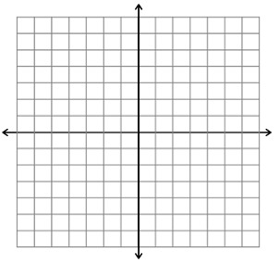
- Cooper is ordering with Amazon Prime, which membership costs him $75 per year. He’s buying mullet wigs that are all the same price, and knows that 4 wigs will cost him $127 (including the membership). Make a table for buying 0 wigs up to 5 wigs, then graph it and make an equation. Label the graph!

x | y

Equation:___________________________________

- Cameron went to Disneyland and wanted to spend the whole day with Peter Pan. He had to pay even just to get Peter Pan to go with him, and then it cost him $16 an hour to spend the day with the Pan. After Cam had spent 4 hours there, he already owed a total of $139. Shoot dang.

  - Make a table and an equation for this situation.
x
y

  - What does the slope represent? ________________________________________________

  - What does the initial value represent? ___________________________________________

- Justin totes needed some delicious Canadian candy bars for his besties for Christmas. He went to the Canadian candy store, but before he even got in, they told him it was for members only. He paid a membership fee, and then paid $2.50 per candy bar. He bought 7 bars for a total of $24. Make a table, graph, and equation from this info.
x
y

Equation:________________________________

- Look at the table below. Make an equation for it, then tell me what the slope and the initial value represent.
Cars cleaned | 5 | 8 | 11 | 14 | 17
Hours | 2 | 4 | 6 | 8 | 10

Equation: __________________________________

Slope: _____________________________________

$y$-intercept: _________________________________

