Name: ________________________________________________ Period: ____________ Number: _____________
Math 8 / 8H
4.3b HW

For each problem, write an equation with the given slope and y-intercept.

- Slope $=\frac{5}{2}$ , y-intercept$=0$

- Slope $=-\frac{7}{2}$ , y-intercept$=3$

- Slope $=1$ , y-intercept$=1$

- Slope $=-1$ , y-intercept$=-2$

Find the slope and y-intercept for each table, and then write an equation.

x | 0 | 1 | 2 | 3 | 4
y | 0 | 2 | 4 | 6 | 8

Slope: ____________
$y$-intercept: ___________
Equation: ________________________

x | 1 | 2 | 3 | 4 | 5
y | 1 | 3 | 5 | 7 | 9

Slope: ____________
$y$-intercept: ___________
Equation: ________________________

x | 0 | 1 | 2 | 3 | 4
y | 5 | 3 | 1 | $$-1$$ | $$-3$$

Slope: ____________
$y$-intercept: ___________
Equation: ________________________

x | $$-3$$ | $$-2$$ | $$-1$$ | 0
y | 7 | 5 | 3 | 1

Slope: ____________
$y$-intercept: ___________
Equation: ________________________

Find the slope and y-intercept for each table, and then write an equation.

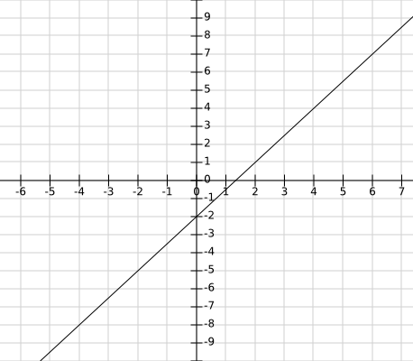 | Slope: ____________  $y$-intercept: ___________  Equation: ________________________

Slope: ____________
$y$-intercept: ___________
Equation: ________________________

