Name: ___________________________________________ Period: __________ Number: _________

4.3b Notes – Writing Equations from Tables and Graphs

Given the following tables, write the equation.
EX #1:
x y | $y$-intercept: ________  Slope: ________  Equation: _______________________
EX #2:
x y | $y$-intercept: ________  Slope: ________  Equation: _______________________

Given the following graphs, write the equation.

EX #3:
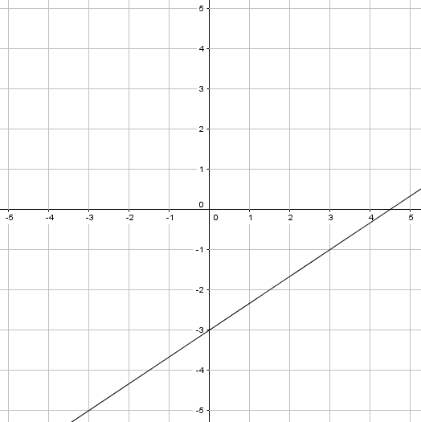 | $y$-intercept: ________  Slope: ________  Equation: _______________________
EX #4:
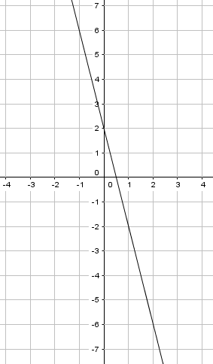 | $y$-intercept: ________  Slope: ________  Equation: _______________________

