5.1a Notes – Solving Systems by graphing

With the equation $y=x+4$ , what is a solution for it?

What is a solution for $y=x+2$ and $y=-4x-3$?
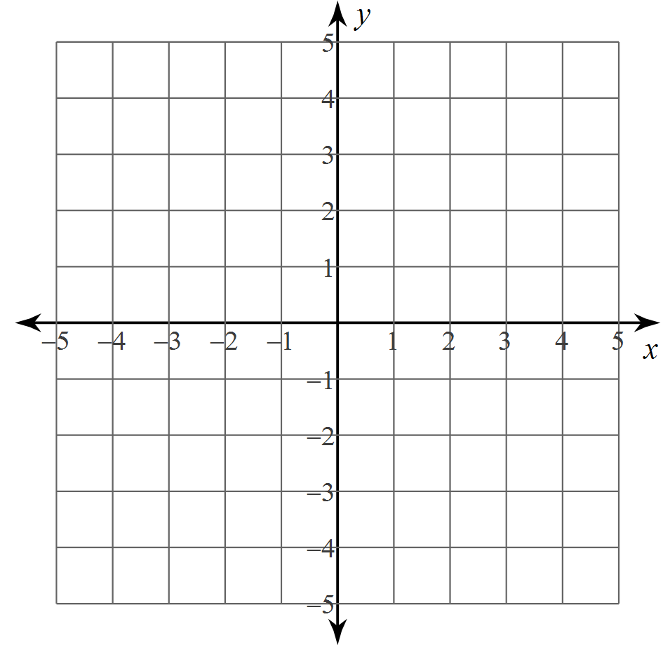
What is a solution for $y=7x+4$and $y=x-2$?

Ex #1: Solve these systems by graphing:  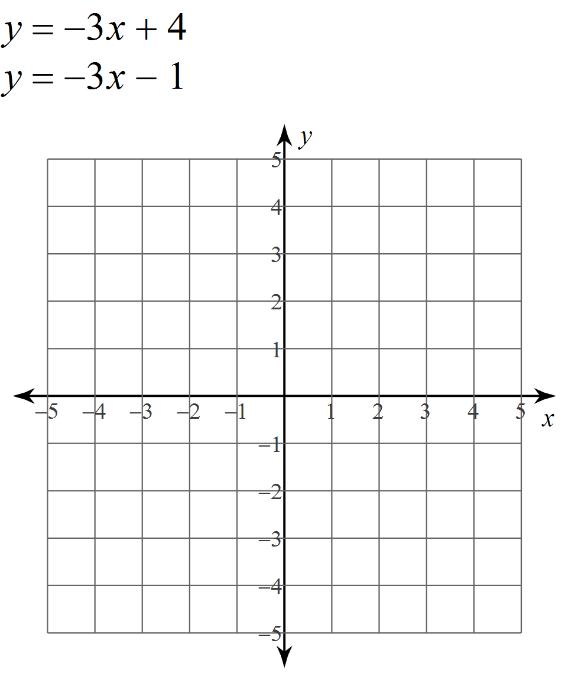 | Ex #2: Solve these systems by graphing:  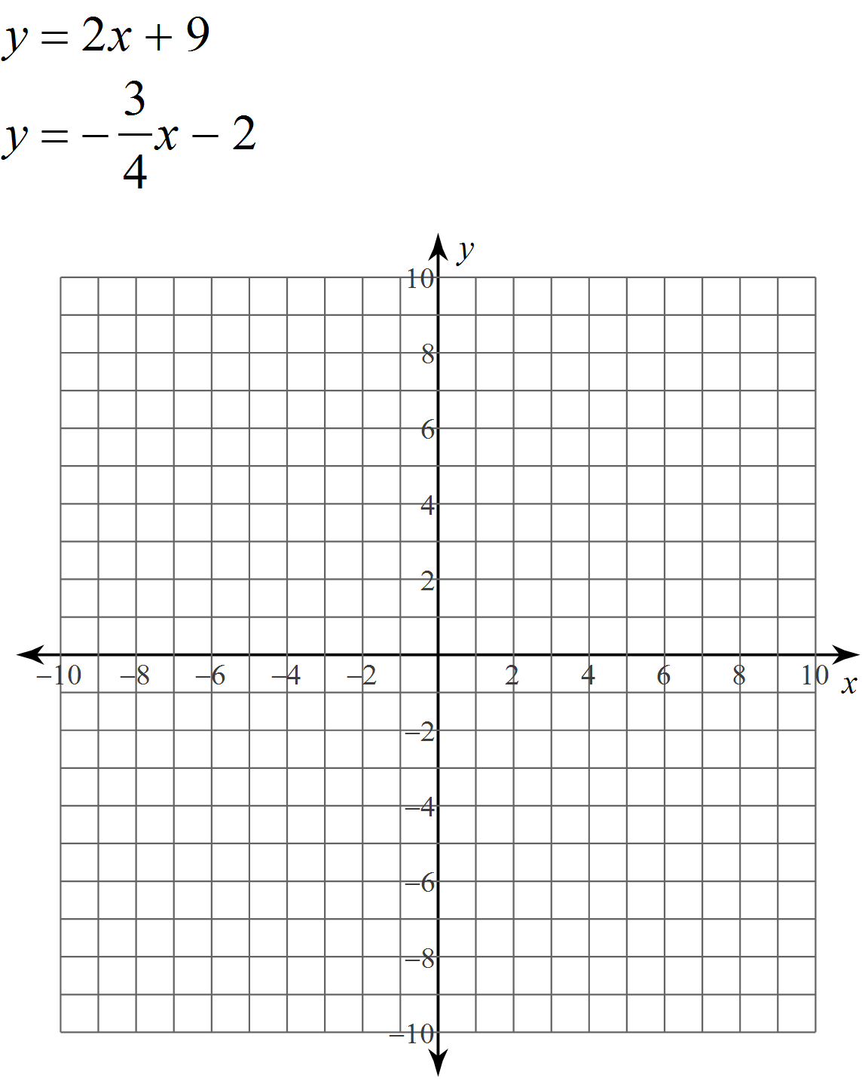

When you solve systems of equations, THREE THINGS CAN HAPPEN:

