**Math 8/8H**

**5.1b #2 HW**

**Graph the two linear equations and find the solution.**

**1.**  **2.** 



**3.**  **4.** 





**5. **

**Find the solution to the given systems.**

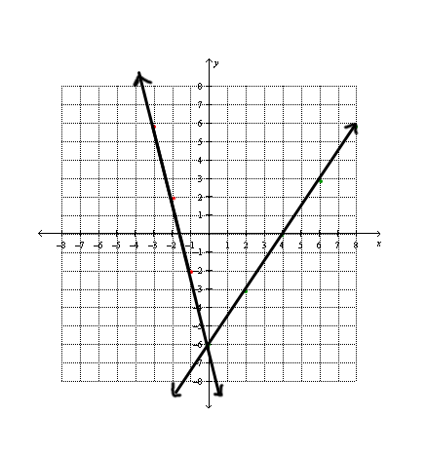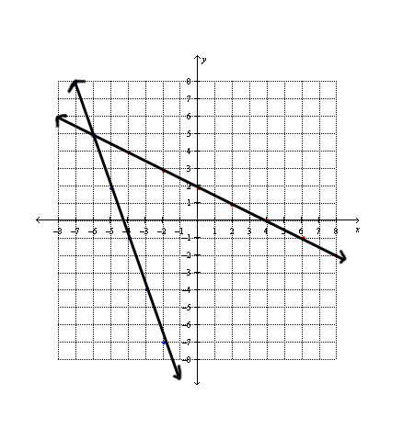**6. 7.**

**Review! – Show all work.**

***Solve the following equations:***

**8.** **9.** 