5.1b Notes – Graphing by Solving for y

When we graph, we want the equation in the form$y=mx+b$.

How can we graph the equation$3y=6x-12$?
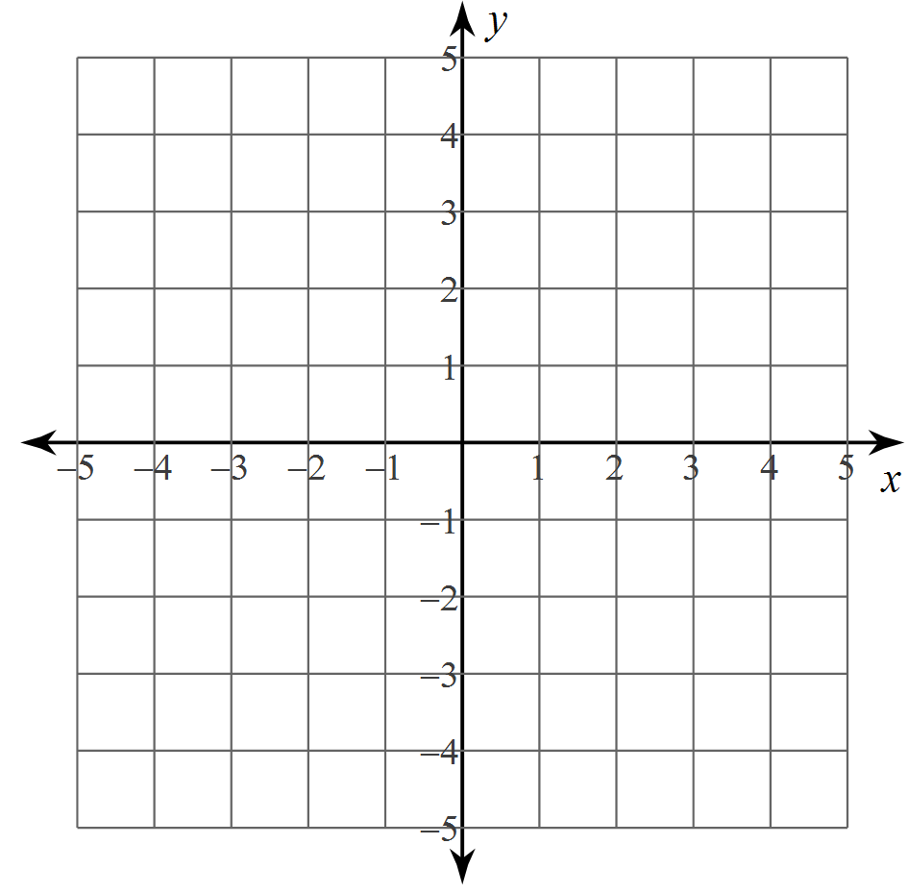
What is a solution for $y=\frac{1}{2}x+3$and $3x+y=-4$?

Ex #1: Solve these systems by graphing:  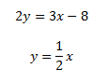  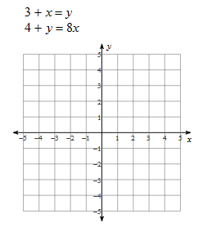 | Ex #2: Solve these systems by graphing:  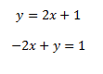  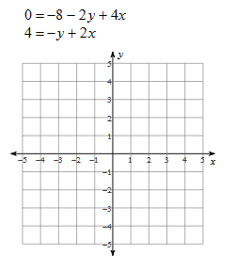

$$y=2x+1$$
$$-2x+y=1$$

