5.1b Notes – Graphing by Solving for y

When we graph, we want the equation in the form$y=mx+b$.

How can we graph the equation$-2x+3y=-12$?
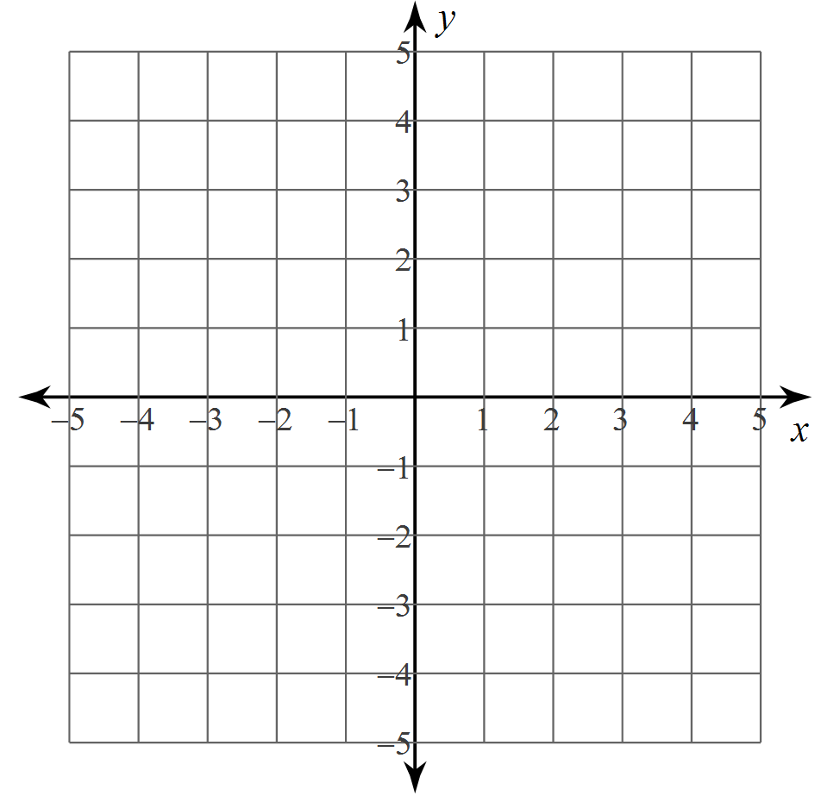
What is a solution for $y=\frac{1}{2}x+3$and $-7x+2y=-6$?

Ex #1: Solve these systems by graphing:  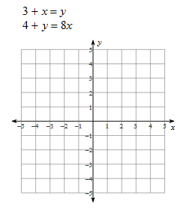 | Ex #2: Solve these systems by graphing:  