Math 8/8H
9.1a #2 HW - Translations
1. Graph triangle $A (-4, -3) B (-2, 1) C (0, -2).$
2. Apply the following transformations and write down the final coordinates of each point.
(Apply each new translation rule to the image from the previous translation.)
- $(x, y)→(x-5, y)$
- $(x, y)→(x, y+4)$
- $(x, y)→(x+7, y-12)$
- $(x, y)→(x+5, y+15)$
- $(x, y)→(x-3, y-6)$
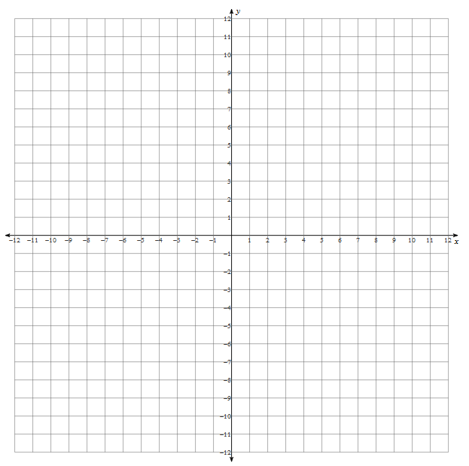
What are the final coordinates?
A’’’’’ _____________ B’’’’’ _____________ C’’’’’ _____________

Write the translation rule that would take you from the pre-image to the final image.
Translation rule: _________________________________

