Name:__________________________________________________________ Period:_________ Number:_________

Math 8/8H
Unit 1-4 Review HW – SHOW YOUR WORK.

- Is 7 a rational number?  YES or NO  Prove it below. | - Change the following decimal into a fraction.  $$0.432432432432…$$
- Is 0.344555666677777… a ration number?  YES or NO  Why? | - Change the following decimal into a fraction.  $$0.72$$
- Convert $\frac{5}{6}$ into a decimal by hand. | - Put these numbers in order from least to greatest.  $$7.5 -7\frac{9}{10} \sqrt{48} -7 -\sqrt{50}$$  _______ _______ _______ _______ _______
- What are the four types of rational numbers? | - Put these numbers in order from least to greatest.  $$1.6 \frac{1}{5} \sqrt{16} -27 \sqrt{5}$$  _______ _______ _______ _______ _______
- Simplify the following expression:  $${\left(\frac{p^{-3}∙w^{9}∙p^{5}}{w^{3}}\right)}^{2}$$ | - A quarter has a mass of $5.67×{10}^{-3}$ kg and a penny has a mass of $2.5×{10}^{-3}$ kg. How many times bigger is the quarter than the penny?
- Simplify the following expression:  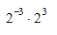 | - Simplify the following expression:  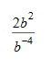
- Solve the following equation:  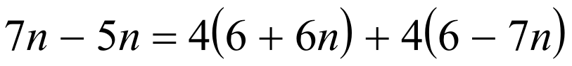 | - Solve the following equation:  $$x^{3}+7=34$$
- Write the equation that goes with the following graph:  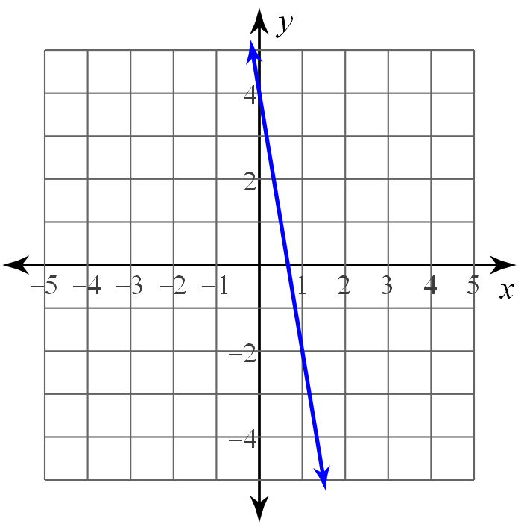 | - I love parrots. I actually steal them. So, on average, when I’m in a room full of pirates, I can steal 1 parrot every 3 minutes. I had some pet parrots already too. After 12 minutes, I had 8 parrots total.  - Make a table to go with my situation.  - Make an equation to go with my situation.  - What does the y-intercept mean?
- Solve the equation.  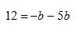 | - Solve the equation.  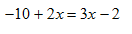
- Solve the equation.  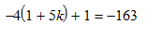 | - Solve the equation.  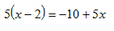
- For the function$f\left(x\right)=2x^{2}-4$, find$f(-3)$. | 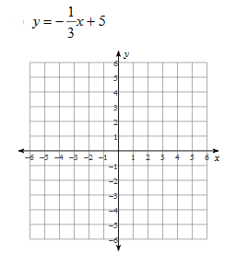
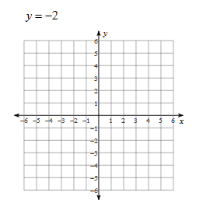 | 